Beauty and Joy of Computing Unit 6 Assessment
Make an interactive poster in Snap! that meets all of the following specifications:
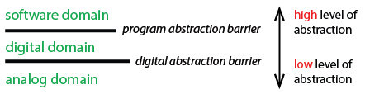
- Explains either how computers work OR the history of computers to an audience of your choosing.

You can go as broad or narrow as you’d like.

For example, you could explain how semiconductors work to a future AP CSP student OR you could provide a brief overview of the history of computers for a younger sibling in elementary school.

- Lets the user interact (e.g., by clicking a sprite, pressing a key, or moving the mouse).
- Showcases the programming knowledge, skills, and experience you’ve developed in this course through the use of sequencing, selection, iteration, and/or abstraction.
- Cites all sources used as comments in the program code.

